**Lab 4 - Ajax**

**Lab 4-1**

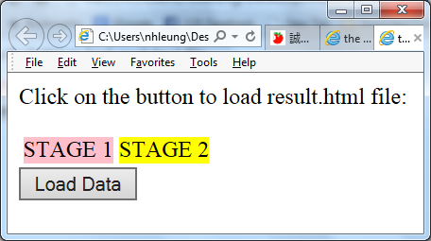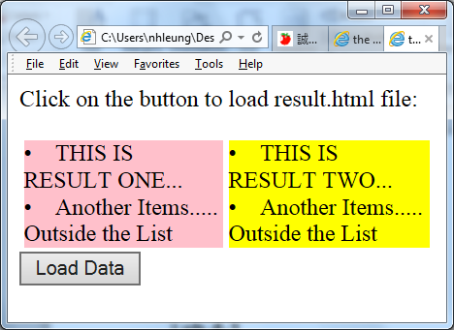Write a jQuery program by using Jason to load two different HTML files onto the current page by clicking a button. The first file is on the left (background-color: pink) while another file is on the right (background-color: yellow).

STAGE 1 Codes:

<body>

<li>THIS IS RESULT ONE...</li>

<li>Another Items.....</li>

Outside the List

</body>

STAGE 2 Codes:

<body>

<li>THIS IS RESULT TWO...</li>

<li>Another Items.....</li>

Outside the List

</body>

**Lab 4-2**

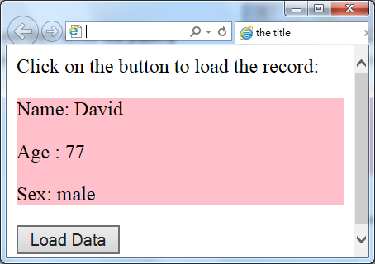Create a Jason file and then write the jQuery program to read the record and then display it as shown in the figure.

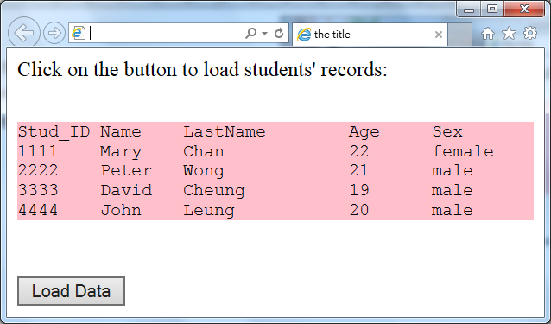**Lab 4-3**

Rewrite the jQuery and JSON files in Lab 4-2 so that four students’ information are displayed with suitable headings as show in the figure.

[ Hints: Use **'\t'** for formatting the data. ]

<body>

<p>Click on the button to load students' records:</p>

<pre>

<div id="stage" style="background-color:pink;">

STAGE

</div>

</pre>

<input type="button" id="driver" value="Load Data" />

</body>

**Lab 4-4**

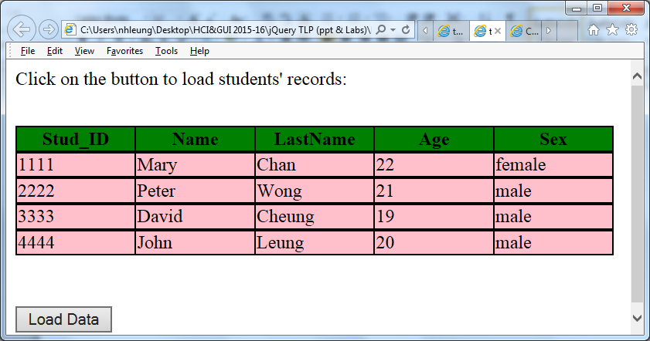

Enhance Lab 4-3 to display the output as below:

**Lab 4-5a**

JSON file can be created using record. For example, Birthday can be separated as Day, Month and Year:

{

"name": ["Mary","John"],

"birthday": [{"day":22, "month":8, "year": 1995},

{"day":12, "month":2, "year": 1993}],

"sex": ["female","male"]

}

Write a program to produce the following output using the above JSON file:

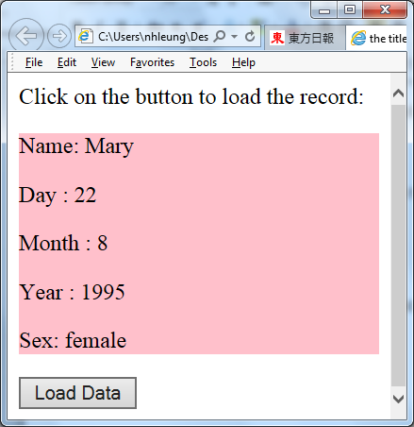

**Lab 4-5b**

Write a program to produce the following output using the above JSON file:

